Supplementary Material

# Supplementary Figures

In addition to the profiles 1A, 2A and 3B shown in Figure 4-6, additional profiles corroborate the results of this study and the conclusions drawn from them.

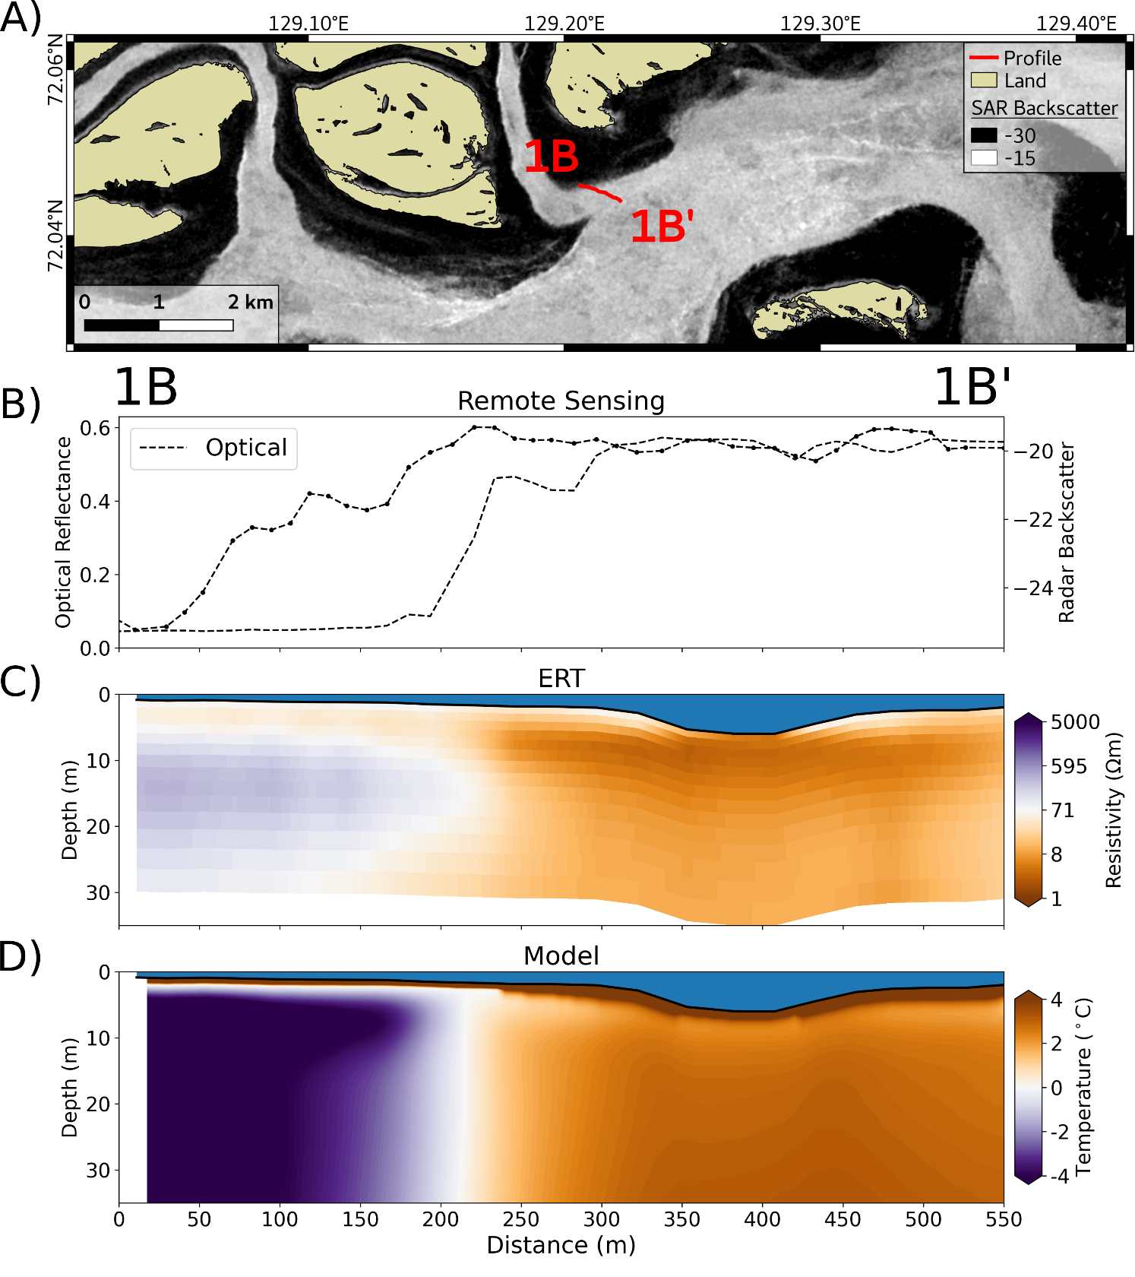

**Supplementary Figure 1**: Profile 1B - 1B’ (for the location see Figure 1). **A**) GPS track of the ERT profile on top of the SAR Sentinel-1 median winter image showing the bedfast (dark) and serpentine (bright) ice. **B**) Extracted optical reflectance and SAR backscatter along the profile. **C**) Cross section of the inverted ERT resistivity along the profile. **D**) Modelled sediment temperature along the profile.

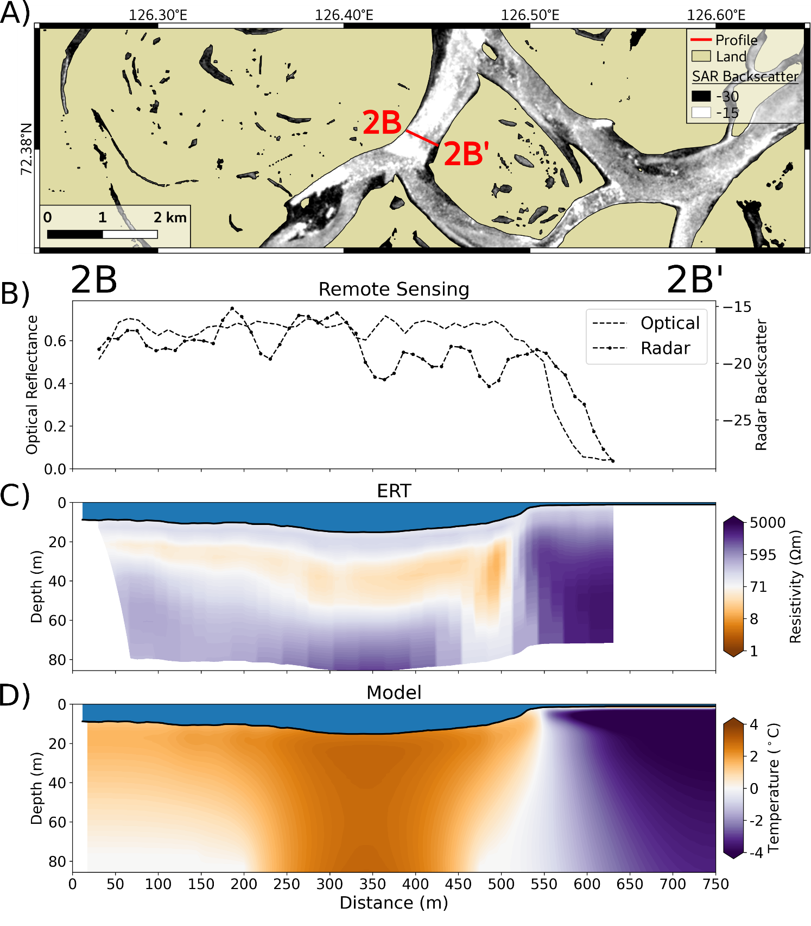

**Supplementary Figure 2**: Profile 2B - 2B’ (for the location see Figure 1). **A**) GPS track of the ERT profile on top of the SAR Sentinel-1 median winter image showing the bedfast (dark) and serpentine (bright) ice. **B**) Extracted optical reflectance and SAR backscatter along the profile. **C**) Cross section of the inverted ERT resistivity along the profile. **D**) Modelled sediment temperature along the profile.

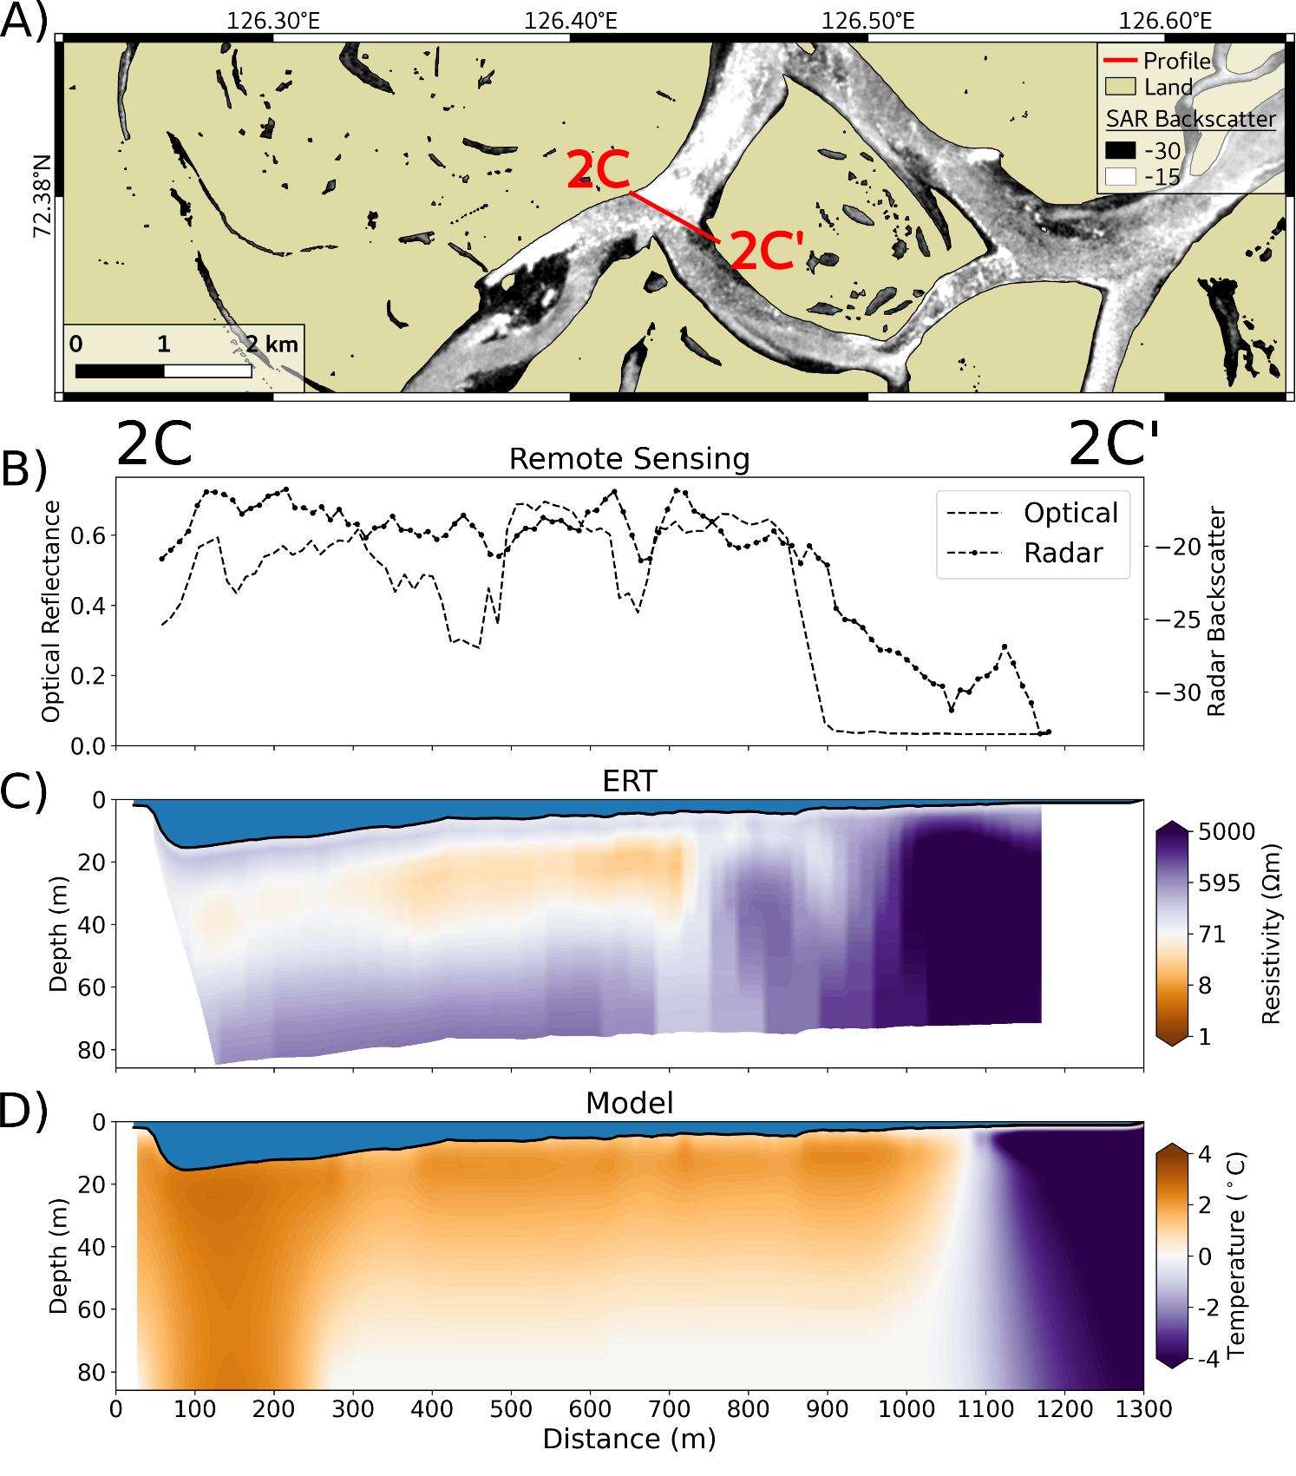

**Supplementary Figure 3**: Profile 2C - 2C’ (for the location see Figure 1). **A**) GPS track of the ERT profile on top of the SAR Sentinel-1 median winter image showing the bedfast (dark) and serpentine (bright) ice. **B**) Extracted optical reflectance and SAR backscatter along the profile. **C**) Cross section of the inverted ERT resistivity along the profile. **D**) Modelled sediment temperature along the profile.

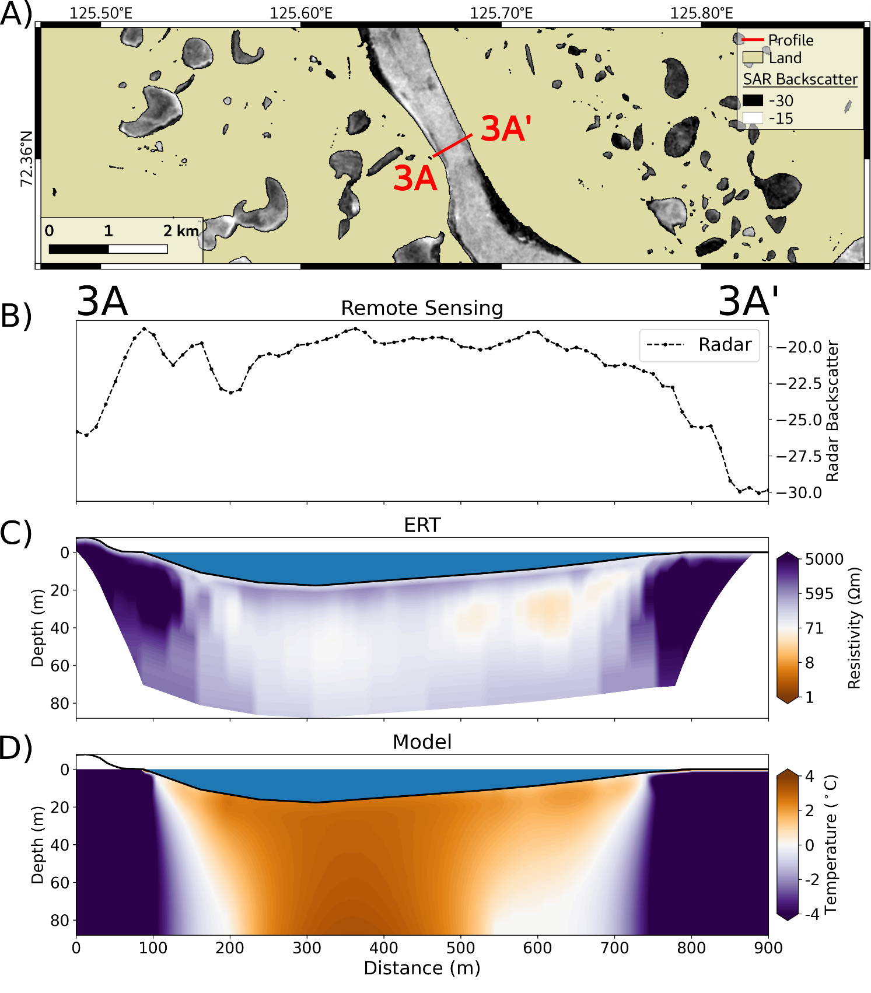

**Supplementary Figure 4**: Profile 3A - 3A’ (for the location see Figure 1). **A**) GPS track of the ERT profile on top of the SAR Sentinel-1 median winter image showing the bedfast (dark) and serpentine (bright) ice. **B**) Extracted optical reflectance and SAR backscatter along the profile. **C**) Cross section of the inverted ERT resistivity along the profile. **D**) Modelled sediment temperature along the profile.

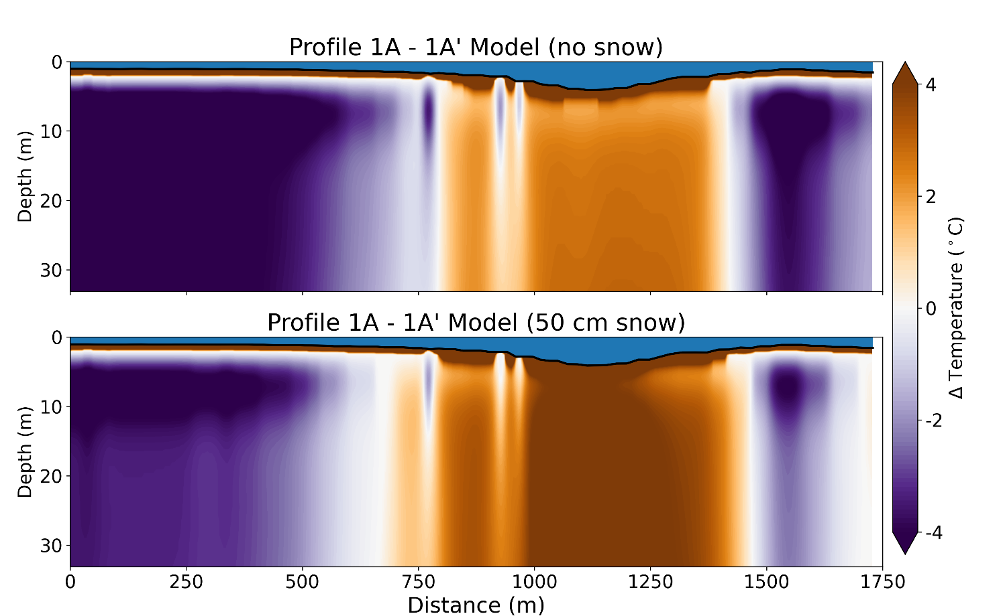

**Supplementary Figure 5**: Modelled sediment temperature along Profile 1A - 1A’ for two snow depth scenarios: no snow (upper figure) and 50 cm snow (lower figure).